**National University of Computer and Emerging Sciences**



Laboratory Tasks 04

*for*

# Web Engineering

*Instructor: Saqib Ameer Email:* [*saqib.ameer@nu.edu.pk*](mailto:saqib.ameer@nu.edu.pk)

# Spring 2024

**FAST School of Computing**

Visual Studio Extenstions which is necessary for Web Engineering Lab

1. Auto Close Tag
2. Auto Import ES6 , TS , JSX
3. Bracket Pair Colorization
4. DOTENV
5. ES7 React Redux Graph
6. ESLint
7. Html to JSX
8. Live Server
9. Thunderclient
10. Prettier Code formatter
11. Path Intellisence

QNO1:- Make three variable in js file and read the values of these variables through form and display using console and innertHtml both methods.

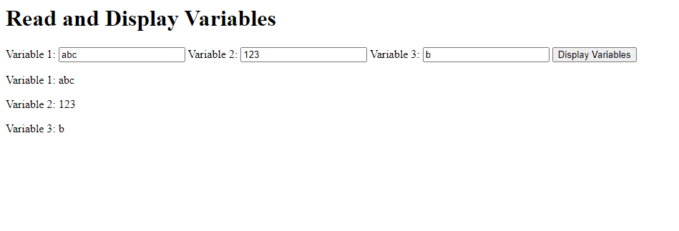

QNo2:- Make a simple webpage to read two numbers and apply all arithmatics operations on these two numbers using javascript code through simple function which is called through onclick Event.

The HTML file includes input fields for two numbers, a button to perform calculations, and a section to display the results.

The CSS file provides basic styling for better readability.

The JavaScript file defines a performOperations function that reads the input values,

performs addition, subtraction, multiplication, and division, and displays the results dynamically.

Input validation is included to ensure that valid numbers are entered.

QNO3:- Make a system that uses HTML, CSS, and JavaScript with arrow functions. Which includes a simple webpage with a button. When the button is clicked, an arrow function is used to handle the event and change the background color of the webpage:

The HTML file includes a button with the ID changeColorButton.

The CSS file styles the body and the button.

The JavaScript file contains an arrow function changeBackgroundColor that generates a random color and changes the background

Color of the body. The click event of the button is then assigned to this arrow function using addEventListener.

When you click the "Change Color" button, the arrow function is called, and the background color of the body is updated to a random color

QNO4:- Make a Program using javascript in which you want to count the votes like online voting system but first to cast the vote system ask your age if age is greater than 18 then you can cast your vote through option like given in screenshot and after that pressing the button function is call onclick event which counts the votes and display these votes in display section.

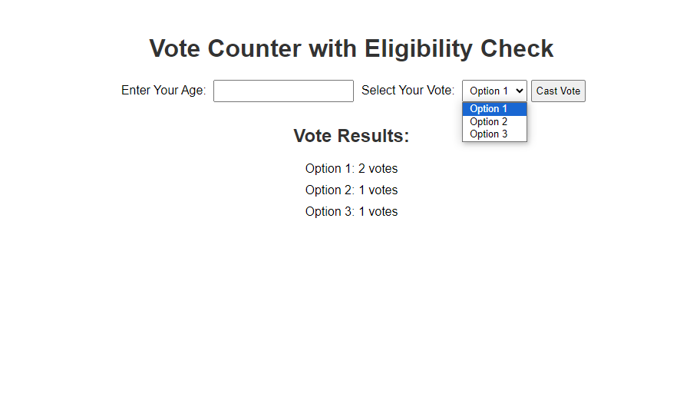

QNO5:- Make a Simple program for Event handling in which make a function to open the open the form through function.

QNO6:- To create a program that stores records in a file, reads the file, and displays the records in an HTML table using JavaScript, HTML, and CSS.

For this note some important points

Use localstorage to stoe the records on chrome or any browser local storage and for using localstorage functions which you can use is given below.

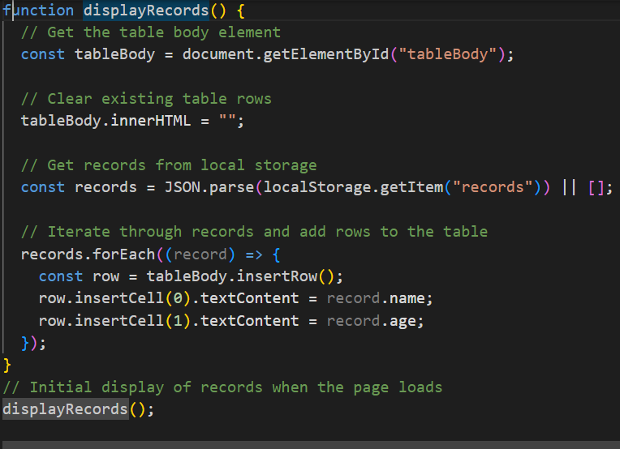

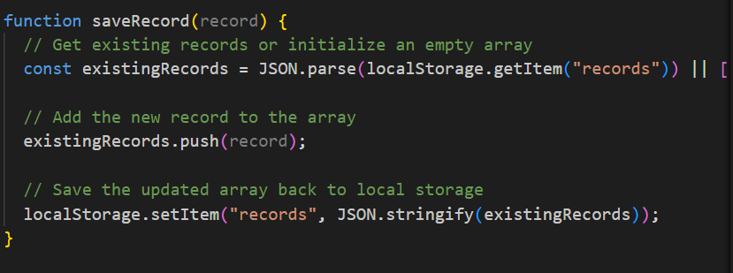

Make three functions

1. Addrecord in which get the values from the inout box to store in the variables

Then check validation just on empty then make an object of all variables

After that call the function of saverecord(record)

Clear all input fileds

In last display all records and call the function of display records.

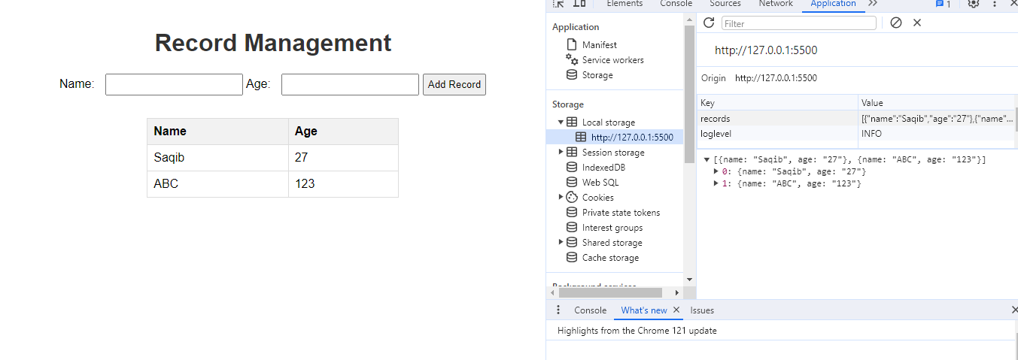

QNO7:- Make a Webpage as given below which is some restutrant billing System in this system you can enter the total bill and tip percentage then no of peoples then click on calculate button to calculate your total bill with tip and tax and after that one person bill automatically calculated.

